**Installing DSpace 6.X for CentOS 7.X**

**Rustam Eyniyev (ASOIU)**

**Start:**

First we log in as root:

su root

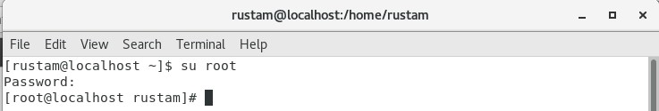

We go to the opt folder and create a “source” folder where the required files will be downloaded:

cd /opt

mkdir source

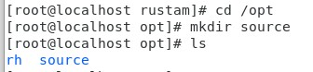

It is needed to download the required files into the “Downloads” folder via GUI and then to move all the downloaded files into the “source” folder. The following are to be downloaded:

1. Java SE 8 JDK (Dspace 6.3 only work with the 8th version). This can be done with the archives from the official site

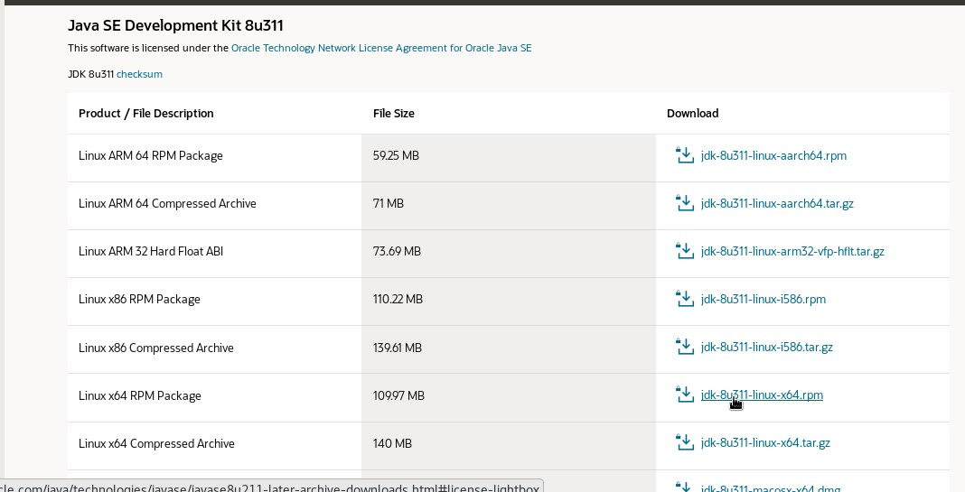

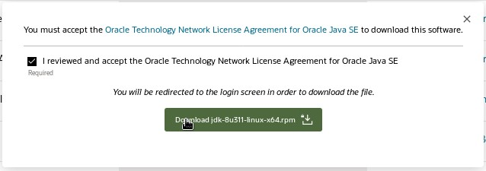

1. Apache Maven (any version earlier than 3.8.1)





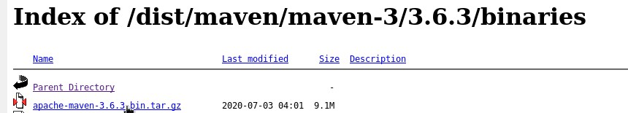

1. Apache Ant (any new version)

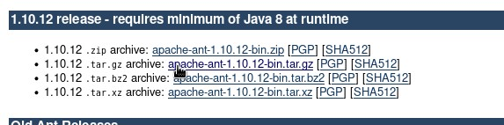

1. Apache Tomcat (any new version)

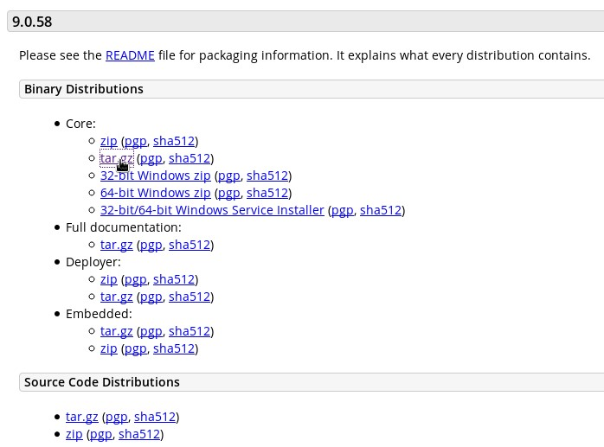

1. DSpace 6.3 (any 6.X version)

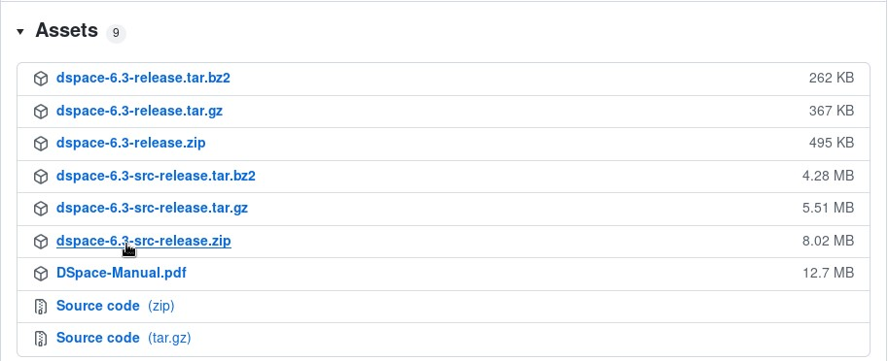

1. PostgreSQL 14

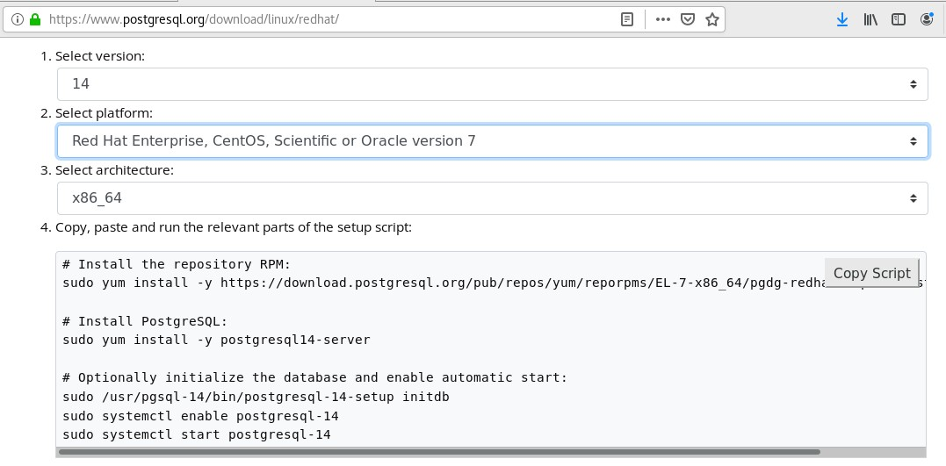

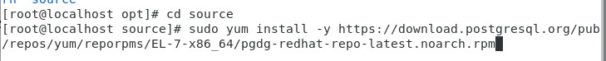

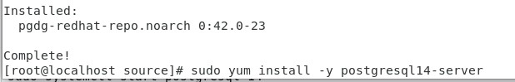

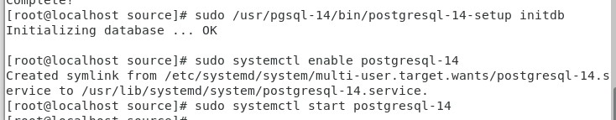

1. Now we install the extension for PostgresSQL to create ”Extension pgcrypto”



Once the required files are downloaded we move the files to “source”

А) In a virtual machine

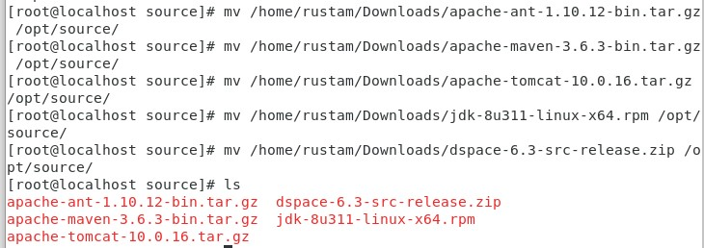



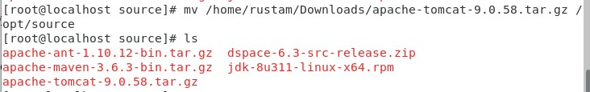

Б) In a real machine

cd “direct path to folder with our files on our main machine” (for example: C:\Users\Rustam\Desktop\HPC files)

scp * root@ip_address:/“direct path to the folder in which to upload files” (for example: /opt/source)

**We begin installing the aforementioned files:**

1. Java JDK

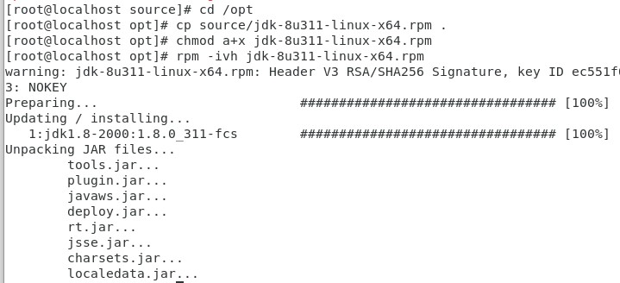

We check which Java version we have

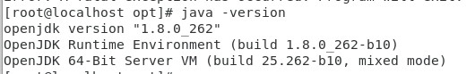

The version we have is OpenJDK, but the needed one is Java SE. To do that we go to the folder of the newly-installed Java JDK.



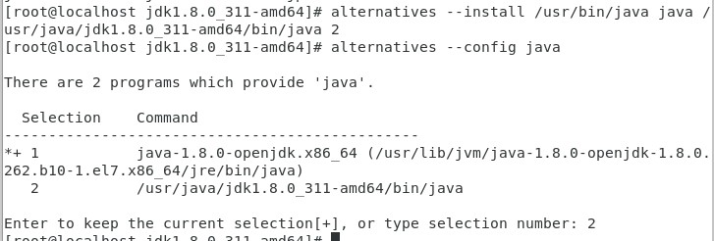

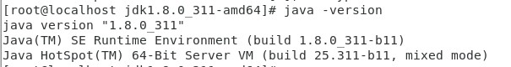

1. Apache Maven



1. Apache Ant



1. Apache Tomcat



**Next we enter the path to the installed files. To do that:**

1. First we create a file under the “java.sh” name



1. We type the following piece of code into the opened document. In order to edit the document we press “Insert”.

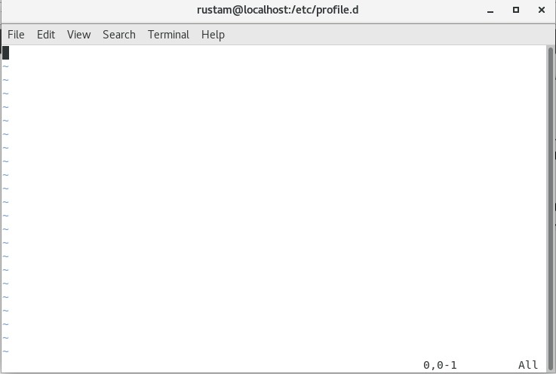

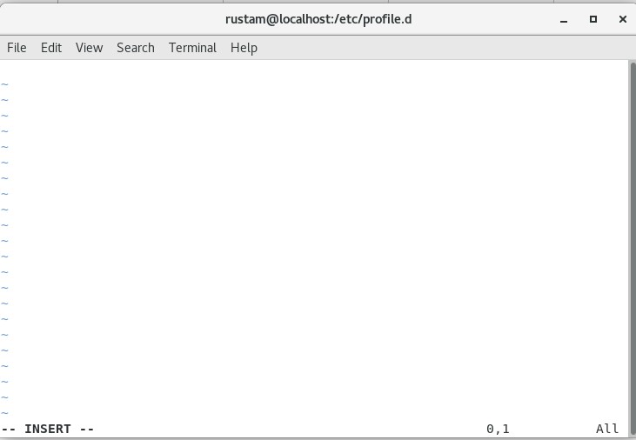

Enter the following code

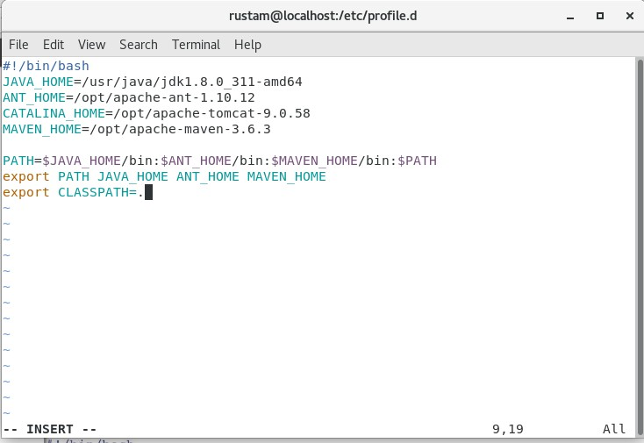

To save the changes :

“Esc” > “:wq!”

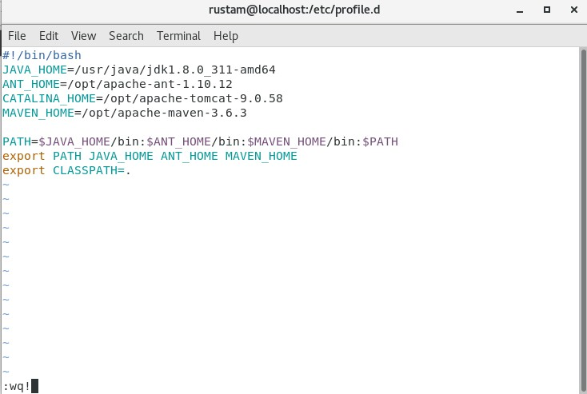

1. We give access to the file



4) We test whether it all works well

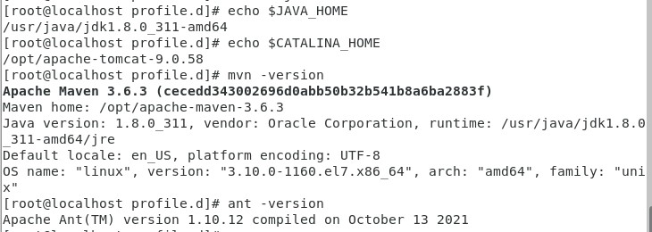

**Now we test whether Tomcat works well:**

1. If the machine is real, then you need:
   1. install http package:

yum install httpd

systemctl start httpd

systemctl enable httpd.service

firewall-cmd --add-service=http –permanent

firewall-cmd --reload

0.2) add port 8080 to firewall:

sudo firewall-cmd --zone=public --permanent --add-port=8080/tcp

sudo firewall-cmd –reload

1. We launch the server

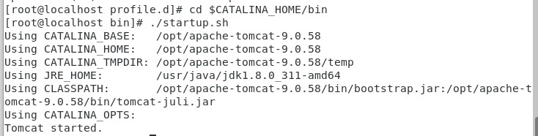

1. We go our browser and enter “localhost:8080” or “127.0.0.1:8080” or your IP address

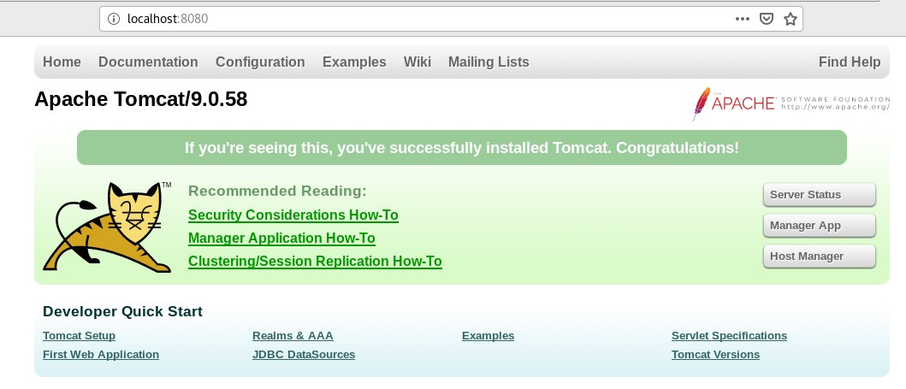

1. We turn off Tomcat

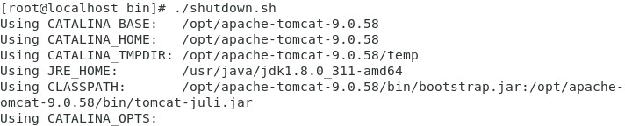

**Now we set up PostgreSQL:**

1. First we find out the location of “pg_hba.conf”. To do that we update the database of the command prompt and then search this file:

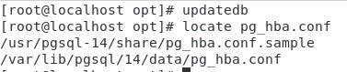

1. We open that file



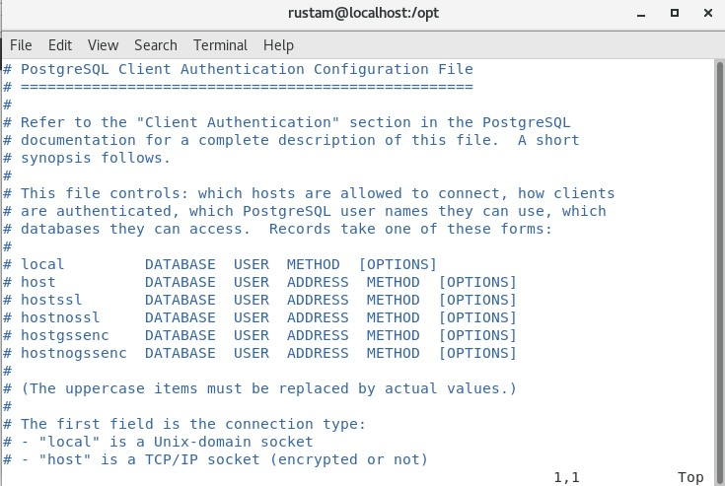

1. We edit the file:

Add this to the IPv4 line:

host dspace dspace 127.0.0.1/32 (or our ip address) md5

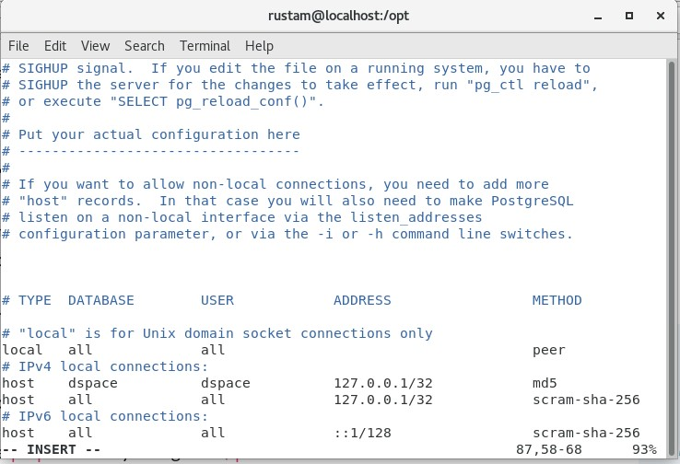

1. We save the file and restart PostgreSQL



1. We add the path to the “bin” folder into the path file



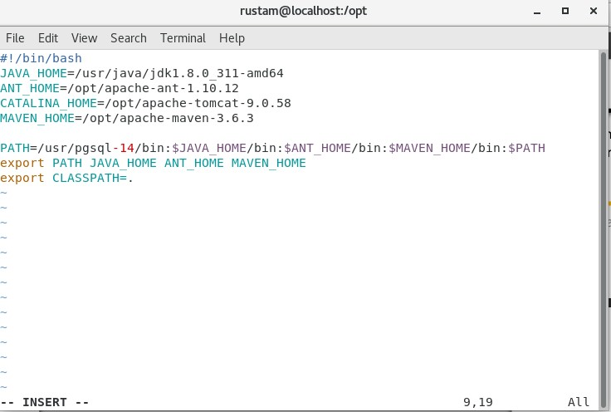



6) We add a password for the PostgreSQL user postgres (root)

su – postgres

then we enter psql in the bash line

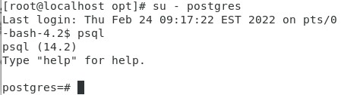



Now we exit the psql terminal and bash.

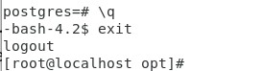

7) Next ,we edit the pg_hba.conf file and change peer to md5, then restart PostreSQL



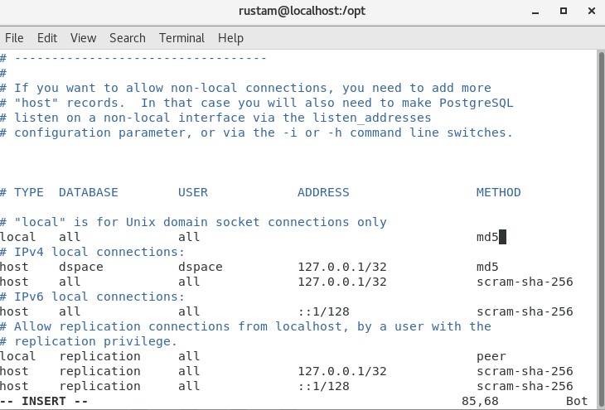



**Let’s configure Dspace:**

1. First, we add the dspace user to the OS.



1. We create the dspace user, then set the password to dspace as well to avoid confusion.

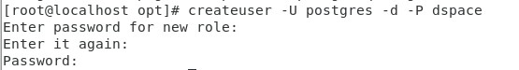

The first 3 lines is the new password which we want to set for the dspace user, and the last line is the password set for the postgres (root) user.

1. We create the dspace database which belongs to the dspace user.



Here we enter the password that was set for the dspace user in the previous step.

1. Now we move to psql again

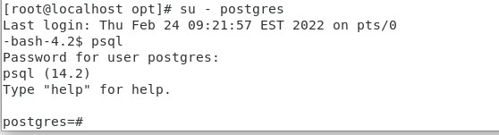

Let’s move to the dspace database

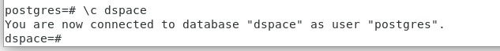

Here we create an extension



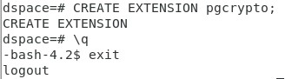

1. We install dspace in the root folder

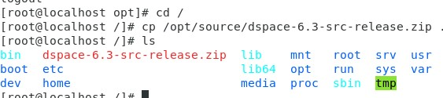

1. Let’s extract the zip file



1. Now let’s create another folder and name it dspace. It will contain our dspace files.

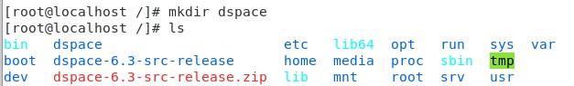

1. We transfer rights for these folders to the dspace user.

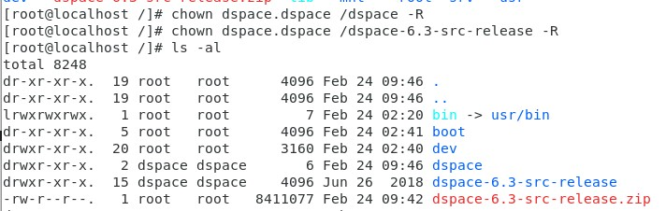

1. We sign in as dspace



1. We go to the folder where the dspace.cfg is stored and open that file.



1. Let’s make sure that db.username and db.password match with those that we set while creating the dspace user’s database. In our case we set dspace for everything so everything checks out. So we can safely exit the file.

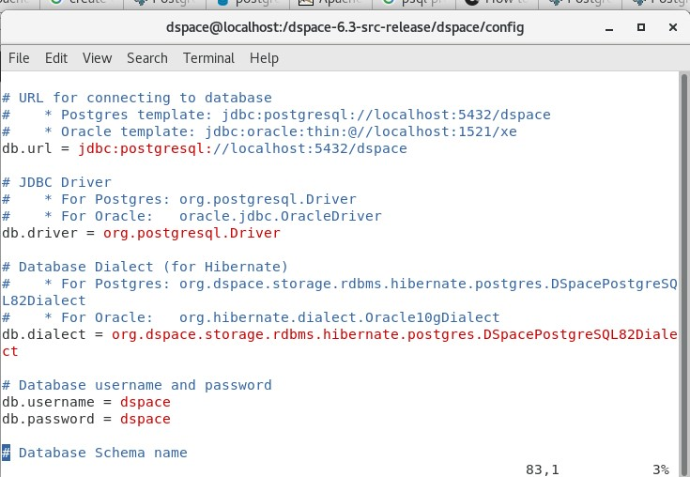

1. Now let’s move on to installation. We go to /dspace-6.3-src-release/dspace



1. Make sure that you have a steady internet connection. First, we install the mvn package. This may take relatively long.



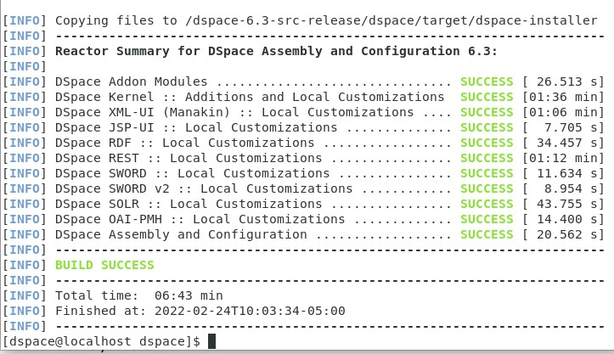

1. Let’s move to the folder containing the installer

cd /dspace-6.3-src-release/dspace/target/dspace-installer/



1. Let’s install ant fresh_install



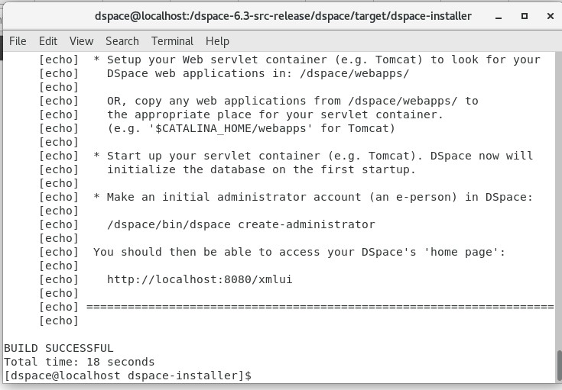

1. Now we need to create an administrator account for the dspace user.

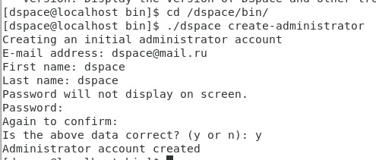

1. Now let’s move to root

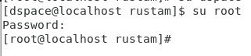

18) Next, we need the jspui.xml and solr.xml files to set the paths of those files in dspace. Don’t forget to make sure that Tomcat is disabled.

19) We begin with jspui.xml



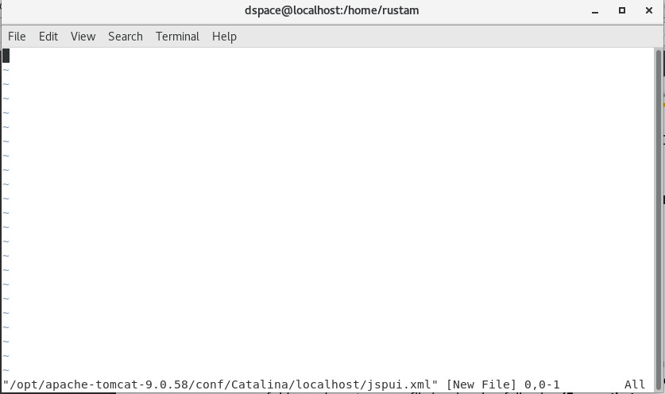

And now we add the following lines to the file and save it

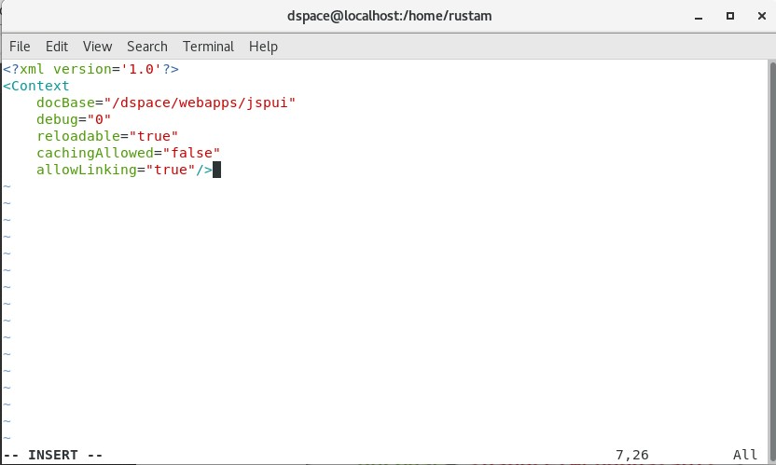

20) We do the same to solr.xml



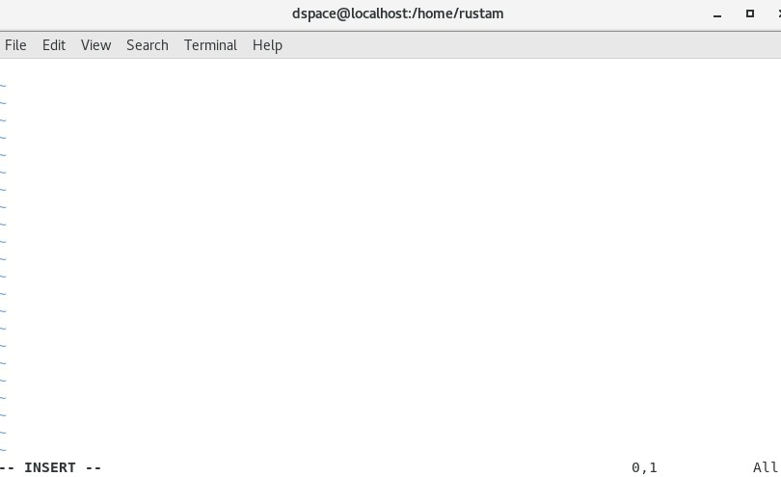

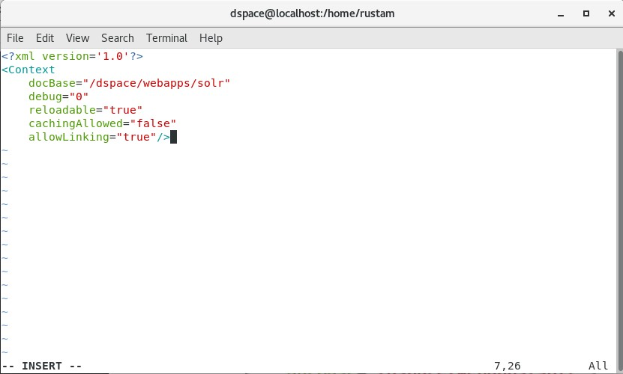

21) We transfer rights to the tomcat dspace user



22) After moving to the dspace user and launch tomcat

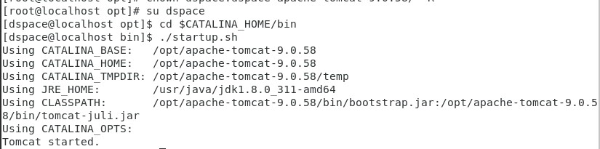

23) Once you go to localhost:8080/jspui you should see the following :

